**Chapter 14 Financial Statement Analysis**

• **Horizontal analysis** evaluates a series of financial statement data over a period of time.

C:\Documents and Settings\Jianhua Jiang\Desktop\1_副本.jpg  
 C:\Documents and Settings\Jianhua Jiang\Desktop\1_.jpg

• **Vertical analysis** evaluates financial statement data by expressing each item in a financial statement as a percentage of a base amount.

• **Ratio analysis** expresses the relationship among selected items of financial statement data.

**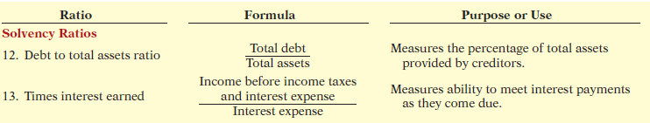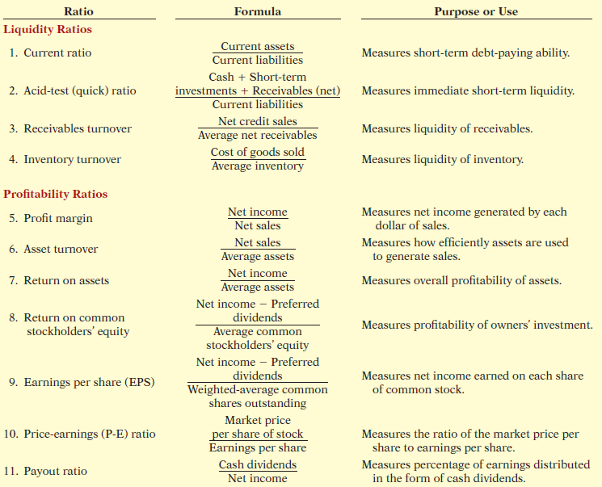**

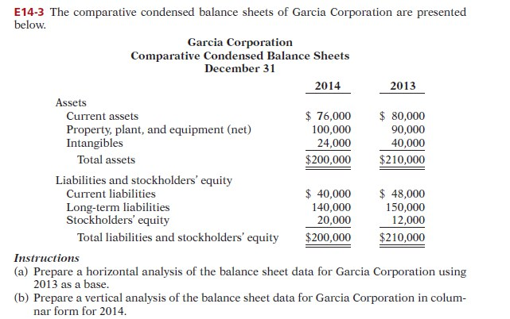

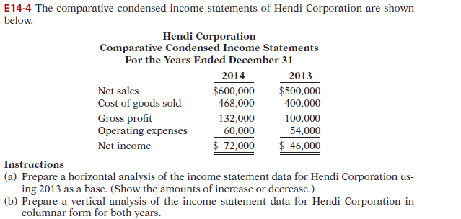

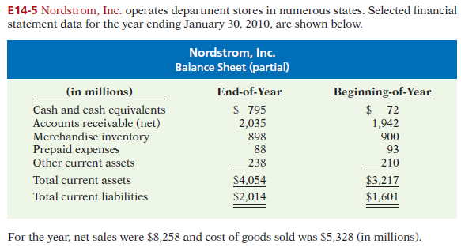

***Instructions***

(a) Compute the four liquidity ratios at the end of the year.

(b) Using the data in the chapter, compare Nordstrom’s liquidity with (1) that of J.C. Penney

Company, and (2) the industry averages for department stores.

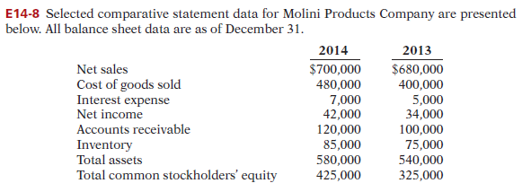

***Instructions***

Compute the following ratios for 2014.

(a) Profi t margin.

(b) Asset turnover.

(c) Return on assets.

(d) Return on common stockholders’ equity.

